**HTML Module 1 Exercise**

At first glance, everything about the website I chose’s webpage, Steam, seemed to be new and different than what I have seen. However, upon closer inspection I was able to pick out a couple familiar tags like <a href> and <head>, lots of Javascripts using the tag <script>, CSS functions, etc. Speaking of CSS functions, I was actually able to open the CSS stylesheet for the page and see several different functions that looked like they had to do with the overall format and style of the page, using lots of color palettes. I was able to change the local page code and just delete a bunch of random lines to break the page, however this was remedied with a simple page refresh. Finally, after looking pretty extensively, I personally could not observe any errors within the code and the console didn’t provide me with any either. I will say, there are a lot of <div> tags that I am pretty excited to learn about!

* File Directory

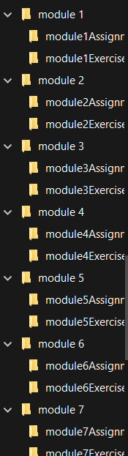

* HTML code

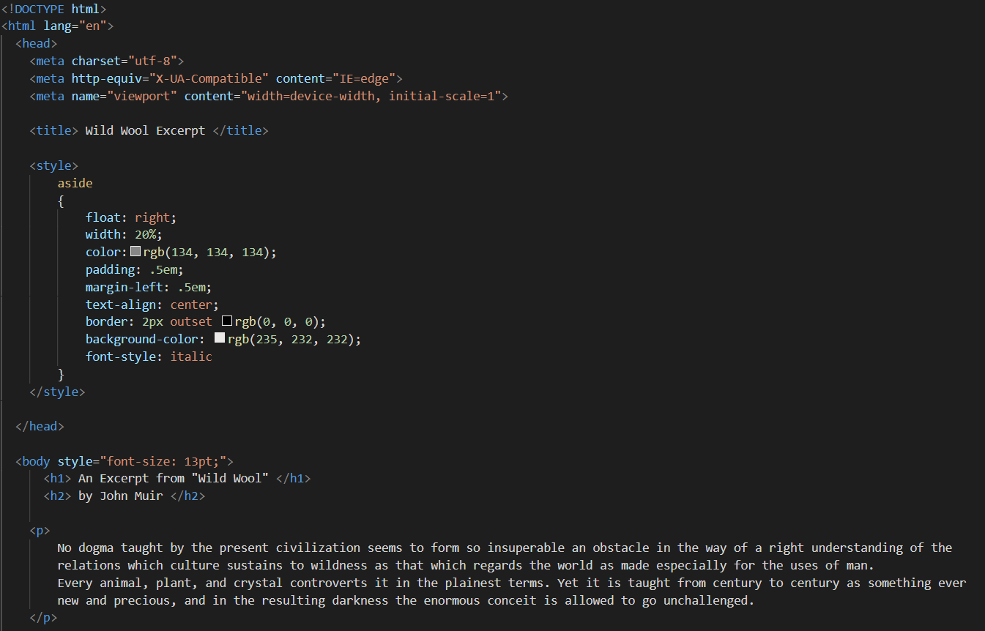

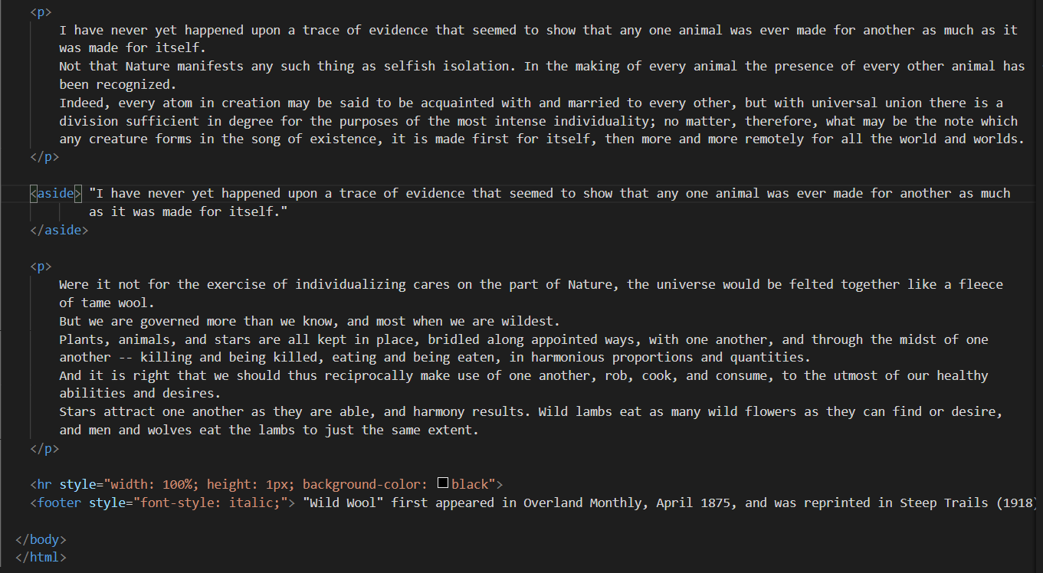

* Resulting page from HTML Code

